**MG996R**

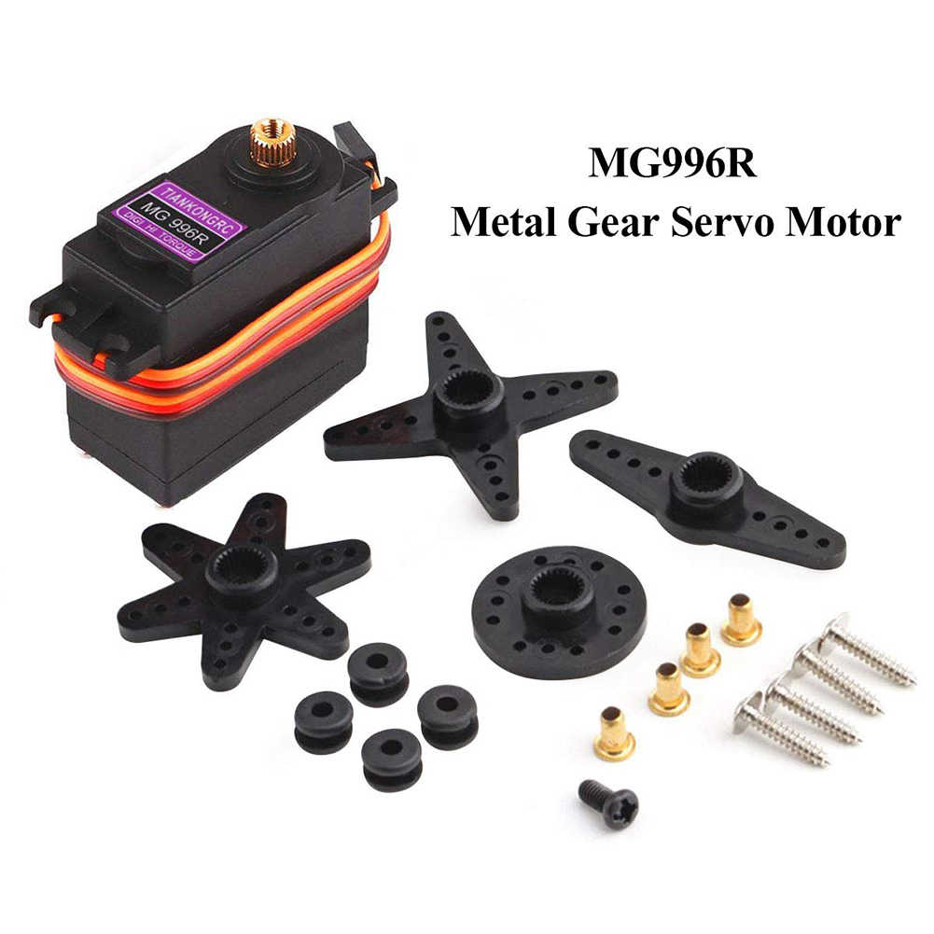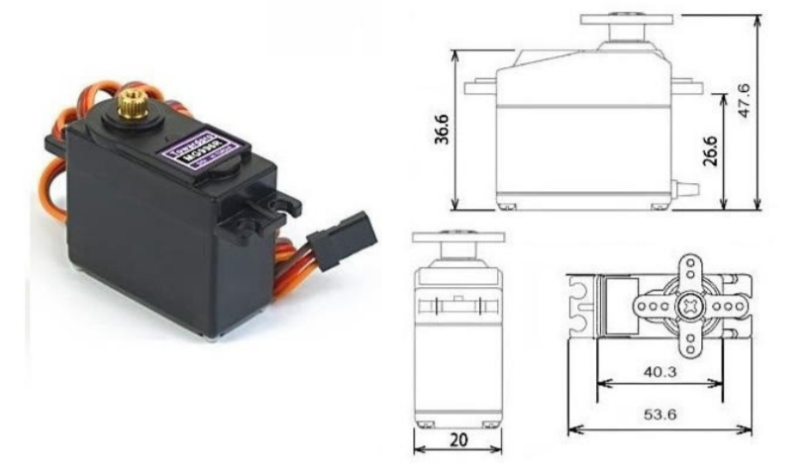

Specification :

Weight: 55 g

• Dimension: 40.7 x 19.7 x 42.9 mm approx.

• Stall torque: 9.4 kgf·cm (4.8 V ), 11 kgf·cm (6 V)

• Operating speed: 0.17 s/60º (4.8 V), 0.14 s/60º (6 V)

• Operating voltage: 4.8 V a 7.2 V • Running Current 500 mA –

• Stall Current 2.5 A (6V)

• Dead band width: 5 µs

• Stable and shock proof double ball bearing design

• Temperature range: 0 ºC – 4.8 V a 7.2 V – 900 mA (6V) double ball bearing design 55 ºC

**LD-260MG**

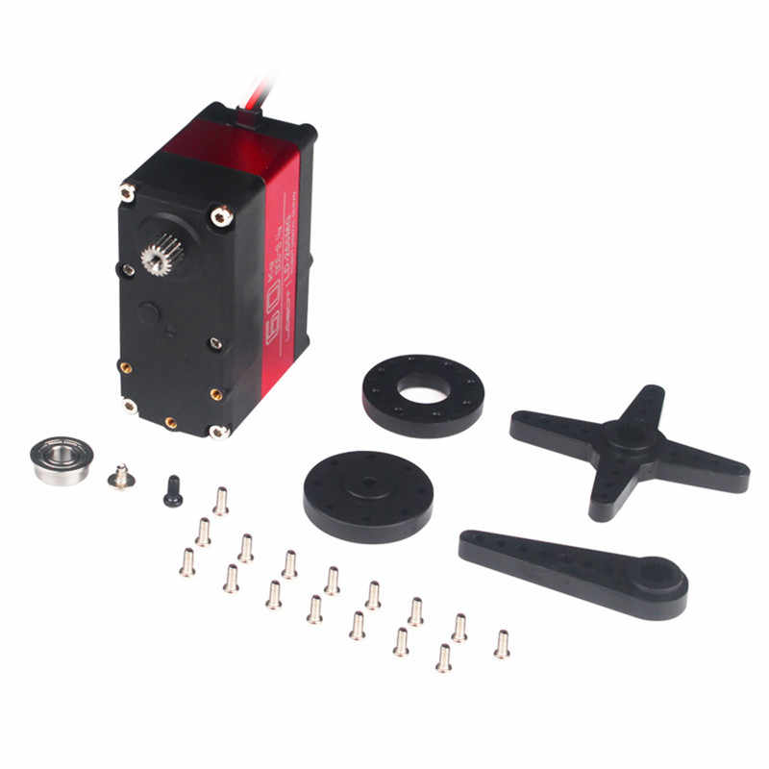

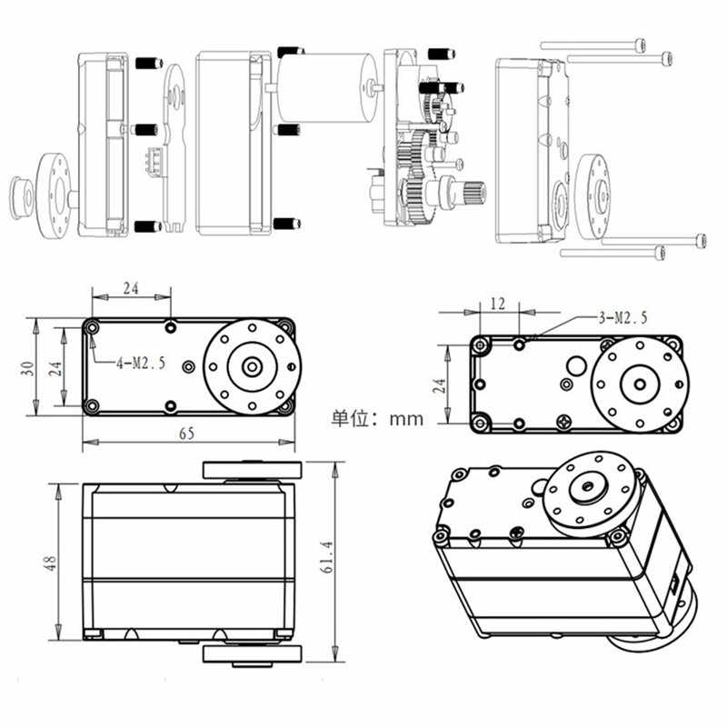

Specification :

Working Voltage: 6.0-8.4V

No-load Speed: 0.17sec/60°(6.0V), 0.15sec/60°(7.4V), 0.13sec/60°(8.4V)

Stall Torque: 58kg.cm(6.0V), 65kg.cm(7.4V), 70kg.cm(8.4V)

Anti-block Current: 3.5A(6.0V), 5A(7.4V), 6.2A(8.4V)

Precision: 3us

Rotation: 180°

Wire Length: 30CM

Gear: Metal

Product Weight: About 163g

Product Size: 65*30*48mm

Application: For RC Robot,RC Car

The different between this two motor for the first motor mg lighter than LD . MG motor have Weight: 55 g and LD motor About 163g . And also the angle for Rotation its different , MG 360° , and LD 180° For LD 60kg large torque and MG 8.5 kgf·cm .So this things depend on your design if you have shoulder and you want moved Logically you need 180 degree and for the hand or leg your design some example you need to move for 360 degree . also the Weight should be calculated .